MacDonagh Junction Savour Kilkenny Young Producers Market
What is the Savour Kilkenny Young Producers Market?
The Savour Kilkenny Young Producers Market is a unique event where fresh thinking young producers create and sell their own homemade produce in a bustling market environment.

Entry Details:
- The Young Producers Market will take place on Saturday 29th October from 1pm-4pm.
- Space is limited to a maximum of 40 participants and will be allocated on a ﬁrst come ﬁrst served basis to those
who register before the closing date of Friday September 30th 2022 by sending in this application form to the address below.
- Entry fee is €5 per person.
- All participants must attend a food hygiene & preparation talk prior to the event, on a date TBC at MacDonagh Junction Shopping Centre.
- Applications open to 1st - 6th year students.

Application Details:

Name Address
Age

Tel. Number Email

School

Class Year Type of food Producing:

Parent’s / Guardian Signature Date

Group (max 3)
or Individual (Tick One)
If a group, list all names:

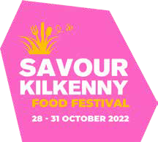

Return your Young Producers Market registration form to:
Young Producers Market, C/O MacDonagh Junction Shopping Centre, Management Suite, MacDonagh Junction, Kilkenny.

